JOURNAL- I

# Team Name: Team 5

Project Name: IoT using LoRaWAN

**Proposed solution by team: (write a good explanation how have you tackled the problem using technologies and explain it precisely)**

**WBS (Work Breakdown Structure) as per your roles mentioned in the team**

Our goal with this project is to create a LoRaWAN network with at least one sensor to generate data based off the behavioural patterns of animals/people, and then visualise the pulled data.

Our solution is going to utilise various software and hardware components including but not limited to Python, Azure, Power Bi, Seeeduino, Raspberry Pi and various sensors.

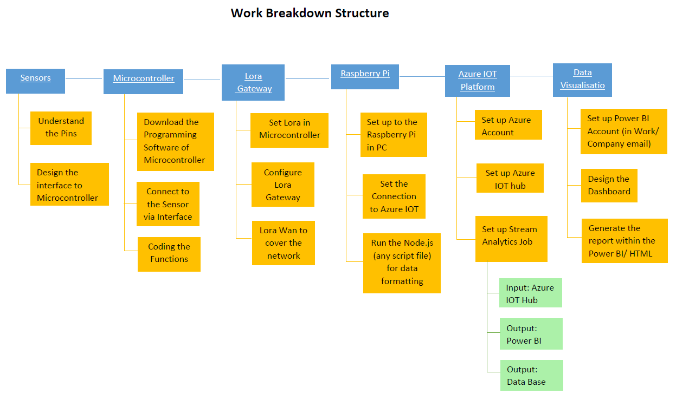

We will almost directly follow the diagram above, apart from certain things tasks to do with the sensors and microcontroller as the microcontrollers will be changed part way through this year. And thus we will initially setup with the devices we are provided, but will return later to make fixes/adapt to the newer, smaller devices. Besides that, matters concerning the LoRaWAN Gateway, Raspberry, Azure IOT platform and Data Visualisation beyond simple setup have not had roles assigned until setup of all physical devices have been configured to work properly.

**Explain what you have learnt new for this project or what skills you have added in your skillset. How are you going to improve your skills in future perspective?**

Team Member – Luis Steve Shigetomi

In this project I learnt the way a project is managed, through tools, team roles, time, effort and coordination. As for tools, I learned how to use Jira, which helps us organize tasks, do sprints and to be prepared in sprint meetings to ensure quality projects and delivery on time. In addition, the use of Raspberry Pi, sensors, Seeeduino, LoraWAN, Microsoft Azure apps, and a new programming language PYTHON, which simplifies extensive coding. I have added to my skillset what I have mentioned above, plus team work and the use of wireframes, which is useful for designing apps.

I plan to improve in the future by the outcome of the project, successful or not, I believe I will know with more certainty what skills I need more dedication, furthermore my strengths and weaknesses.

Team Member - Joel Andrew Morran

Thus far from this project I have learnt about Python and its differences from java, this will be used further on in the project for the analysis of data we receive from our device. I have also learnt that NPM install is NOT NPN install I am sure I will remember this in the future. In addition to this I have learnt about Power Bi for data visualization as well as Seeeduino LoraWan, Seeeduino Arduino, Microsoft Azur Edge for IOT and their various setup methods and how to attempt for them to communicate between one and other. I have also learnt about the differences between raspberry PI gen 1 and gen 3 and gen 3B+ as I had pre-existing knowledge of gen 1. In addition to this I have learnt about Jira and its uses for software development projects and its importance as it has the potential to be useful in the future. I have also refreshed my existing knowledge of the agile development process. I am sure this during this project much of what I do will be helpful to improve my existing skills for a future perspective and that I will also learn new skills to add to this.

Team Member – Michael Owczarek

I have already learnt quite a lot while undertaking this project, covering both hardware and software. Hardware wise, I have learnt about LoRaWAN and its use cases, system architecture and processes, along with Raspberry Pi. In terms of software, I have been focusing on learning Azure and its many functionalities, primarily Power BI. Additionally, whilst already familiar with Jira, it has been good to use it in a more real-world approach. Also, being the team contact, I have also developed my communication skills as well as my ability to work well in a team.

I will further develop all of these skills throughout the projects duration with the hopes of applying them in the real-world post-graduation.

Team Member – James Curnow

Being involved in a team-based project has taught me a lot already. Especially in regards to the software development methodology that is Agile. In principle the concept of Agile is somewhat confusing to grasp, but putting the methodology into practice has helped immensely with my understanding. Furthermore, I have also learnt the importance of thorough planning when undertaking a project of a higher scale. The skills that I have added to my skillset through the project include; becoming more adept when using Jira and improved team communication. In the future I plan on improving my skills through research and practice based on the tasks I will be performing.

Team Member – Remi Petit

Over the course of the semester, I have attained a multitude of additional skills pertaining to the development of this project. Such as research done into learning and understanding python for it’s uses within context of manipulating data pulled from our devices. In addition to greater understanding surrounding LoRaWAN hardware, software and it’s many components within the Internet of Things. As well as building upon my knowledge of the workings of the Agile methodology and applying it to real life.

To continue improving my skills for future events, I intend to prepare myself by committing to further research for the multiple possibilities our project may take as well as potential challenges I will face later in my career.